Adding a DLL to Component Services

Step 1 - Go to Component Services under Administrative Tools.

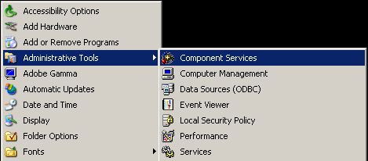

Step 2 – Create a Application.

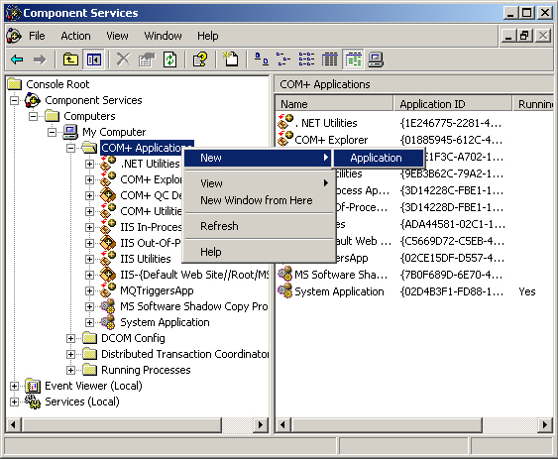

Step 3 – Create an Empty Application

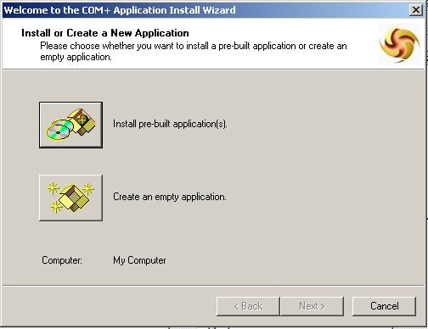

Step 4 – Name the Application and select Server Application.

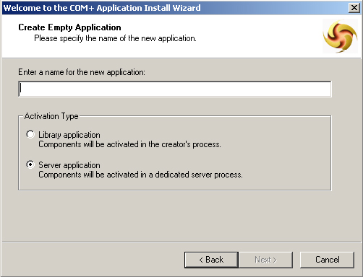

Step 5 – This user. Interactive User must be logged in. Otherwise the component will not work.

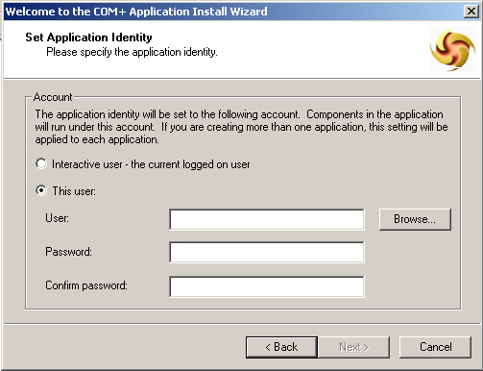

Step 6 – Add the DLL.

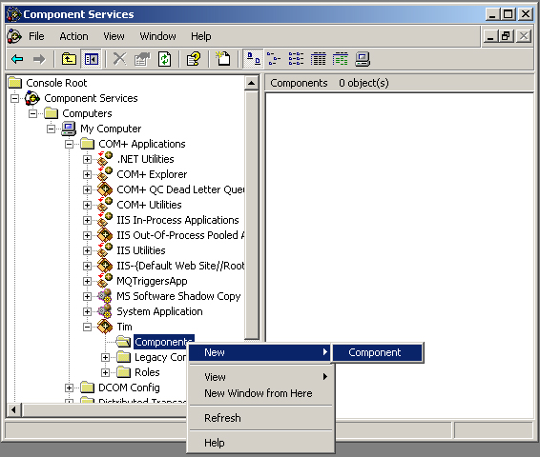

Step 7 – Select Install new Component(s). Click next.

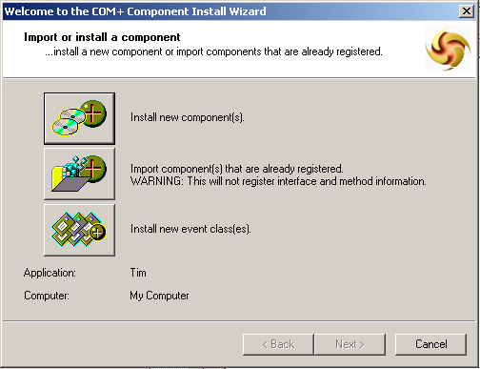

Then choose the DLL.

You will need the CSLID from the properties of the Com Object you just registered:

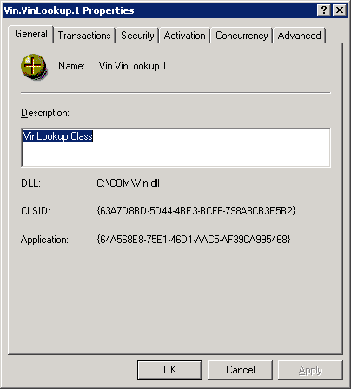

In SQL
Run this script to test put your CLSID in place of the one below

DECLARE @object int
DECLARE @hr int
DECLARE @src varchar(255), @desc varchar(255)
EXEC @hr = sp_OACreate '{63A7D8BD-5D44-4BE3-BCFF-798A8CB3E5B2}',
@object OUT
IF @hr <> 0
BEGIN
EXEC sp_OAGetErrorInfo @object, @src OUT, @desc OUT
raiserror('Error Creating COM Component 0x%x, %s, %s',16,1, @hr, @src, @desc)
RETURN
END

If you get this error:

Msg 15281, Level 16, State 1, Procedure sp_OACreate, Line 1
SQL Server blocked access to procedure 'sys.sp_OACreate' of component 'Ole Automation Procedures' because this component is turned off as part of the security configuration for this server. A system administrator can enable the use of 'Ole Automation Procedures' by using sp_configure. For more information about enabling 'Ole Automation Procedures', see "Surface Area Configuration" in SQL Server Books Online.

You need to run the following to enable OLE

sp_configure 'show advanced options', 1
RECONFIGURE
GO
sp_configure 'Ole Automation Procedures', 1
GO
RECONFIGURE

In our case with the Vin.dll

Run this to test it. It should call the vinversion method and return what version off the dll this is:

DECLARE @object int
DECLARE @hr int
DECLARE @src varchar(255), @desc varchar(255)
EXEC @hr = sp_OACreate '{63A7D8BD-5D44-4BE3-BCFF-798A8CB3E5B2}',
@object OUT
IF @hr <> 0
BEGIN
EXEC sp_OAGetErrorInfo @object, @src OUT, @desc OUT
raiserror('Error Creating COM Component 0x%x, %s, %s',16,1, @hr, @src, @desc)
RETURN
END

DECLARE @property varchar(255)
EXEC @hr = sp_OAGetProperty @object, 'vinversion', @property OUT
IF @hr <> 0
BEGIN
EXEC sp_OAGetErrorInfo @object
RETURN
END
PRINT @property

EXEC @hr = sp_OAMethod @object, 'vinversion'
IF @hr <> 0
BEGIN
EXEC sp_OAGetErrorInfo @object
RETURN
END

You can use the DCOM explorer to tell you the methods for this dll

